COFFEE SHOP SALES & CUSTOMER
TRANSACTION ANALYTICS

Presented By,
Sabari B

TABLE OF CONTENTS

S.NO | PARICULARS | PAGE.NO
1 | Project Objective | 1
1.1 | Data Understanding | 2
2 | Data Cleaning Process & Transformation | 3-6
2.1 | Handling Missing Value | 3
2.2 | Duplicate Records Removal | 4
2.3 | Data type Conversion | 5
2.4 | Checking Invalid Values | 6
2.5 | Text Standardization | 6
3 | Excel Analysis & Formulas | 7-9
4 | Pivot Tables & Pivot Charts | 10-12
5 | Interactive Dashboard | 13-16
5.1 | KPI Cards | 13
5.2 | Slicers and Timeline Interaction | 14
5.3 | Dashboard Charts and Formatting | 16
6 | Insights Reports | 17-18
6.1 | Key Findings and Business Insights | 17
6.2 | Business Recommendations | 18
7 | Conclusion | 19

Coffee Shop Sales & Customer
Transaction Analytics
Project Objective:
The main objective of the Coffee Shop Sales Performance & Transaction Analytics project is to analyse coffee shop transaction data using Microsoft Excel to understand sales performance, product demand, store performance, and monthly sales trends.
The first objective is to inspect and clean the raw dataset by checking missing values, duplicate records, data types, invalid values, and inconsistent text formats. This helps prepare the data for reliable analysis.
Another objective is to use Excel formulas and functions to calculate important sales metrics, including total revenue, total quantity sold, transaction count, and average revenue per transaction.
The project also aims to compare revenue across different store locations and product categories and analyse product demand based on the quantity sold. These comparisons help identify strong-performing categories, products, and store locations.
Another objective is to analyse monthly revenue trends from January to June 2023 to understand how sales performance changes over the available period.
Microsoft Excel tools, including formulas, PivotTables, PivotCharts, KPI cards, slicers, and a date timeline, are used to summarize and present the results through an interactive dashboard.
Finally, the project aims to identify meaningful business insights and provide practical recommendations based on the analysis. This project demonstrates the use of Excel for data cleaning, analysis, visualization, and business reporting.

Raw Data

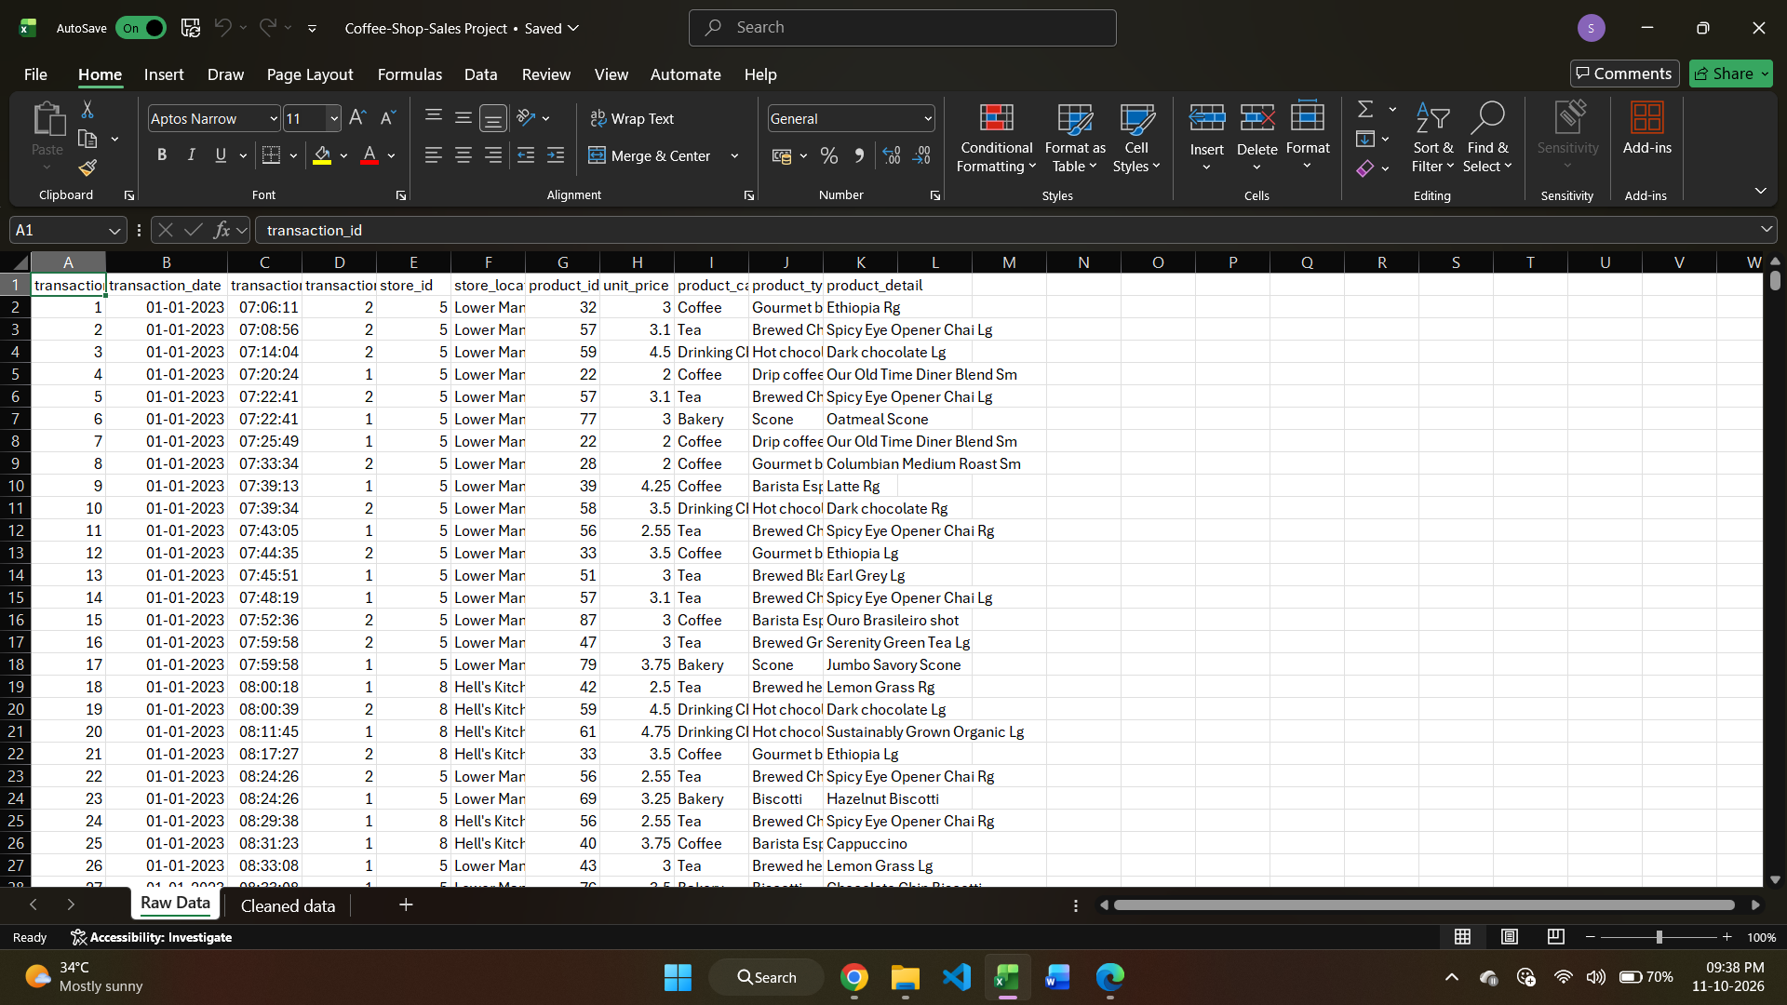

Data Understanding:

Data Sourced By: Kaggle.
Tool Used: Microsoft Excel.
Number of Column:11.
Original Records: 1,50,765.
Records After Cleaning: 1,49,110.

Column description:
Column Name | Description
Transaction_id | Unique or identifying transaction reference
Transaction_date | Date of the transaction
Transaction_time | Time of the transaction
Transaction_qty | Quantity of products purchased
Store_id | Store identification number
Store_location | Location of the store
Product_id | Product identification number
Unit_price | Price per unit of the product
Product_category | Category to which the product belongs
Product_type | Type of product sold
Product_detail | Specific product name or description

2) Data Cleaning Process & Transformation

2.1) Handling Missing Value :
After checking all 11 columns of the Coffee Shop Sales dataset, no missing values were found. All records contained values in the available fields, so no missing-value treatment was required. Therefore, no values were filled, replaced or removed as part of this process. This ensures that the dataset can proceed to the next stage of data cleaning without
requiring any specification for missing values.
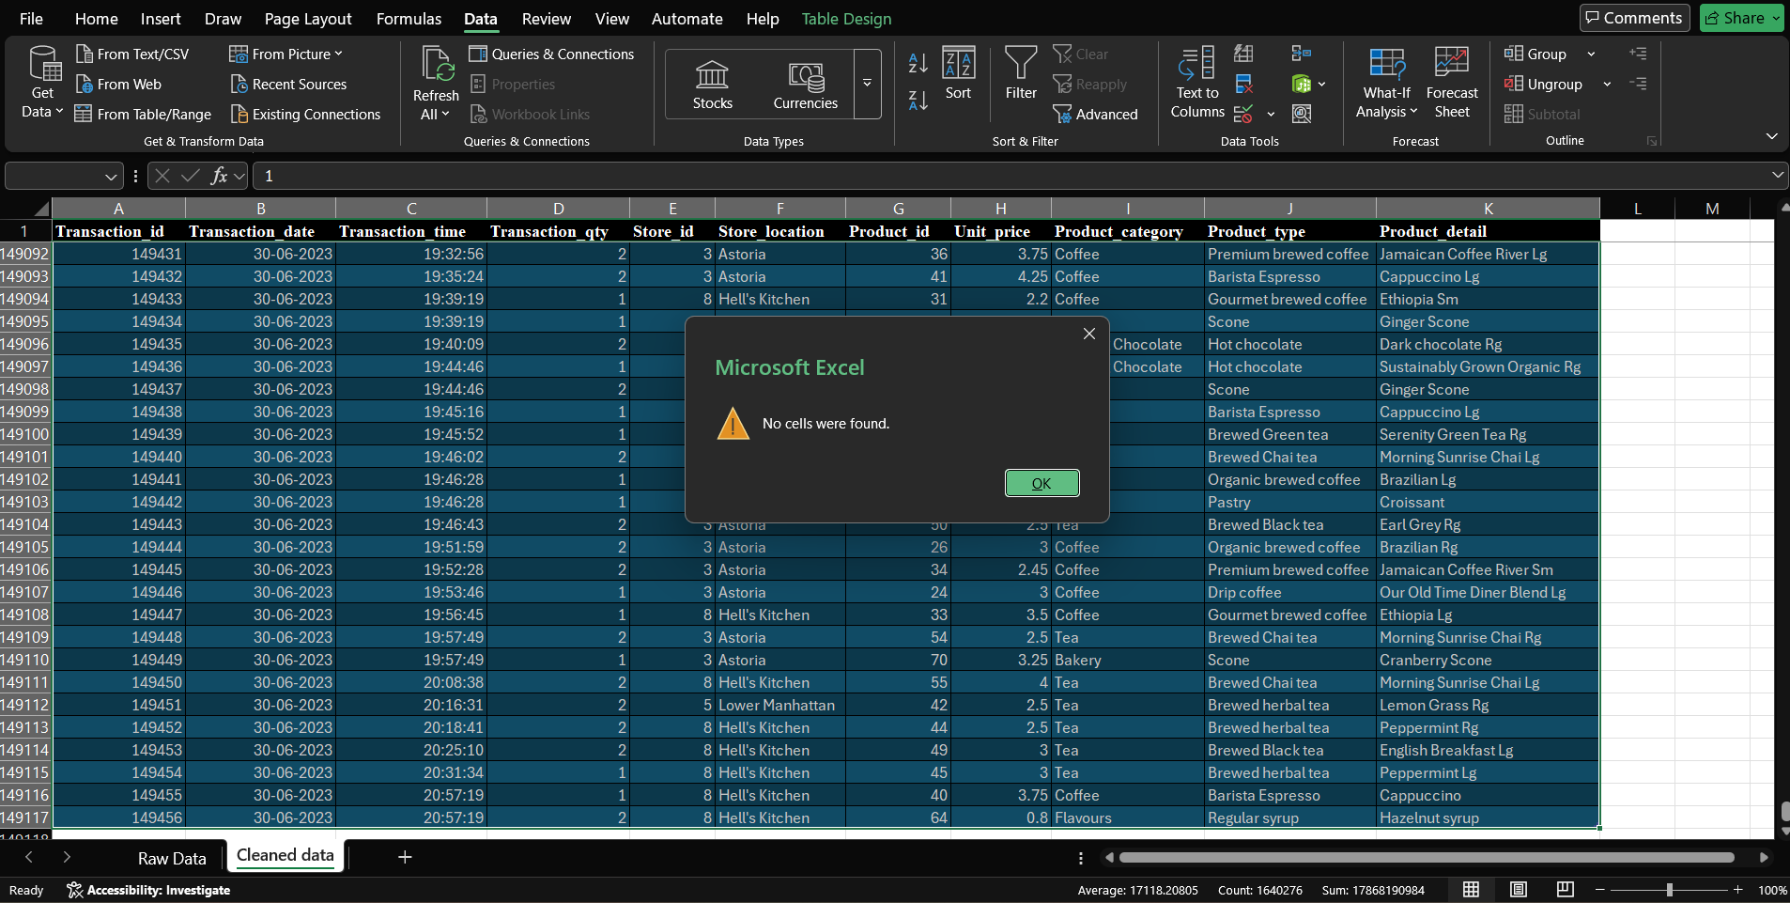

2.2) Duplicate Records Removal:
The dataset was checked for duplicate records using the Remove Duplicates feature in Microsoft Excel. During this process, 1,649 duplicate rows were identified and removed from the dataset. Removing duplicate records helps prevent repeated data from affecting sales calculations, transaction counts and product performance analysis. This step improves the consistency of the dataset and helps ensure that the subsequent analysis provides more reliable results.

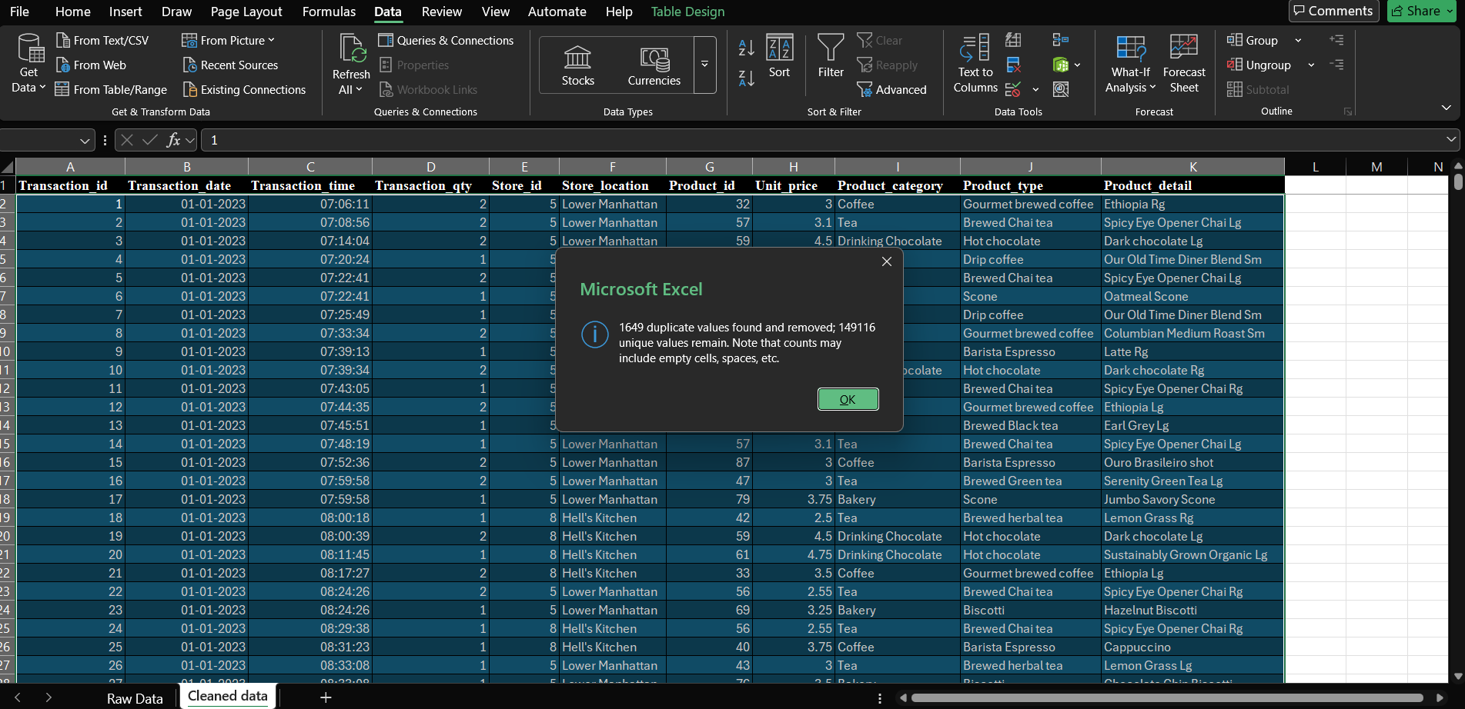
2.3) Data Type Conversion:
The data type conversion process was performed to ensure that each column in the Coffee Shop Sales dataset used an appropriate data format. Transaction dates and times were checked to ensure they could be used for time-based analysis, while transaction quantities and unit prices were checked for numerical calculations. Text-based fields, including product categories, product types, product details and store locations, were reviewed to ensure consistency. Correct data types are essential for performing accurate calculations, creating PivotTables and analysing sales performance over different time periods.
Column | Data type
Transaction_id | Number
Transaction_date | Short date
Transaction_time | Time
Transaction_qty | Number
Store_id | Number
Store_location | Text
Product_id | Number
Unit_price | Number
Product_category | Text
Product_type | Text
Product_detail | Text
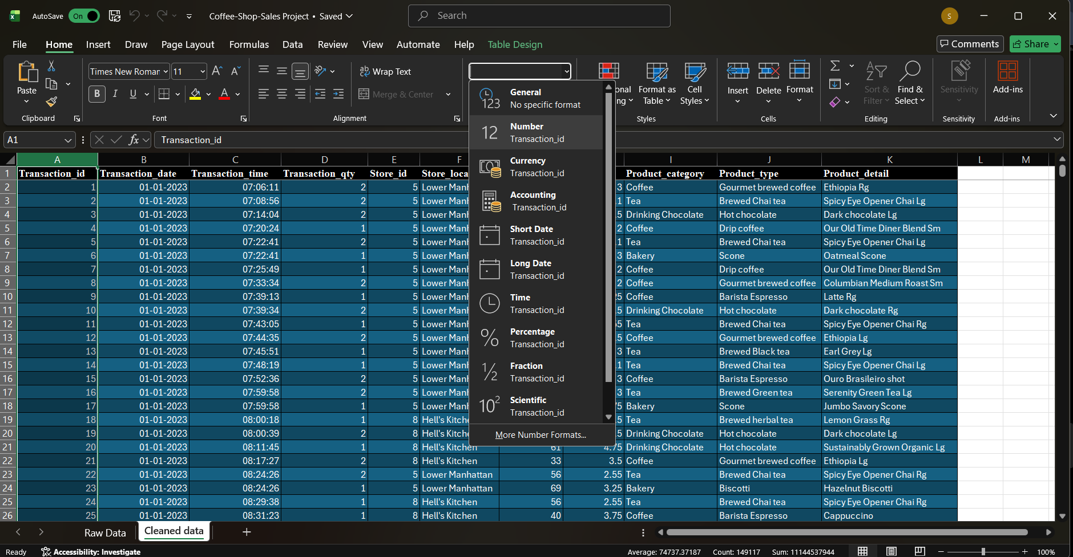
2.4) Checking Invalid Values :
The Coffee Shop Sales dataset was checked for invalid values to ensure the accuracy and reliability of the analysis. Important numerical fields, including transaction quantity and unit price were examined for zero, negative or unexpected values. Transaction dates and times were also reviewed to identify any invalid entries or values outside the expected range. This process helps prevent incorrect records from affecting revenue calculations, product performance comparisons and time-based sales analysis. Any unusual values identified were reviewed before deciding whether corrective action was necessary.
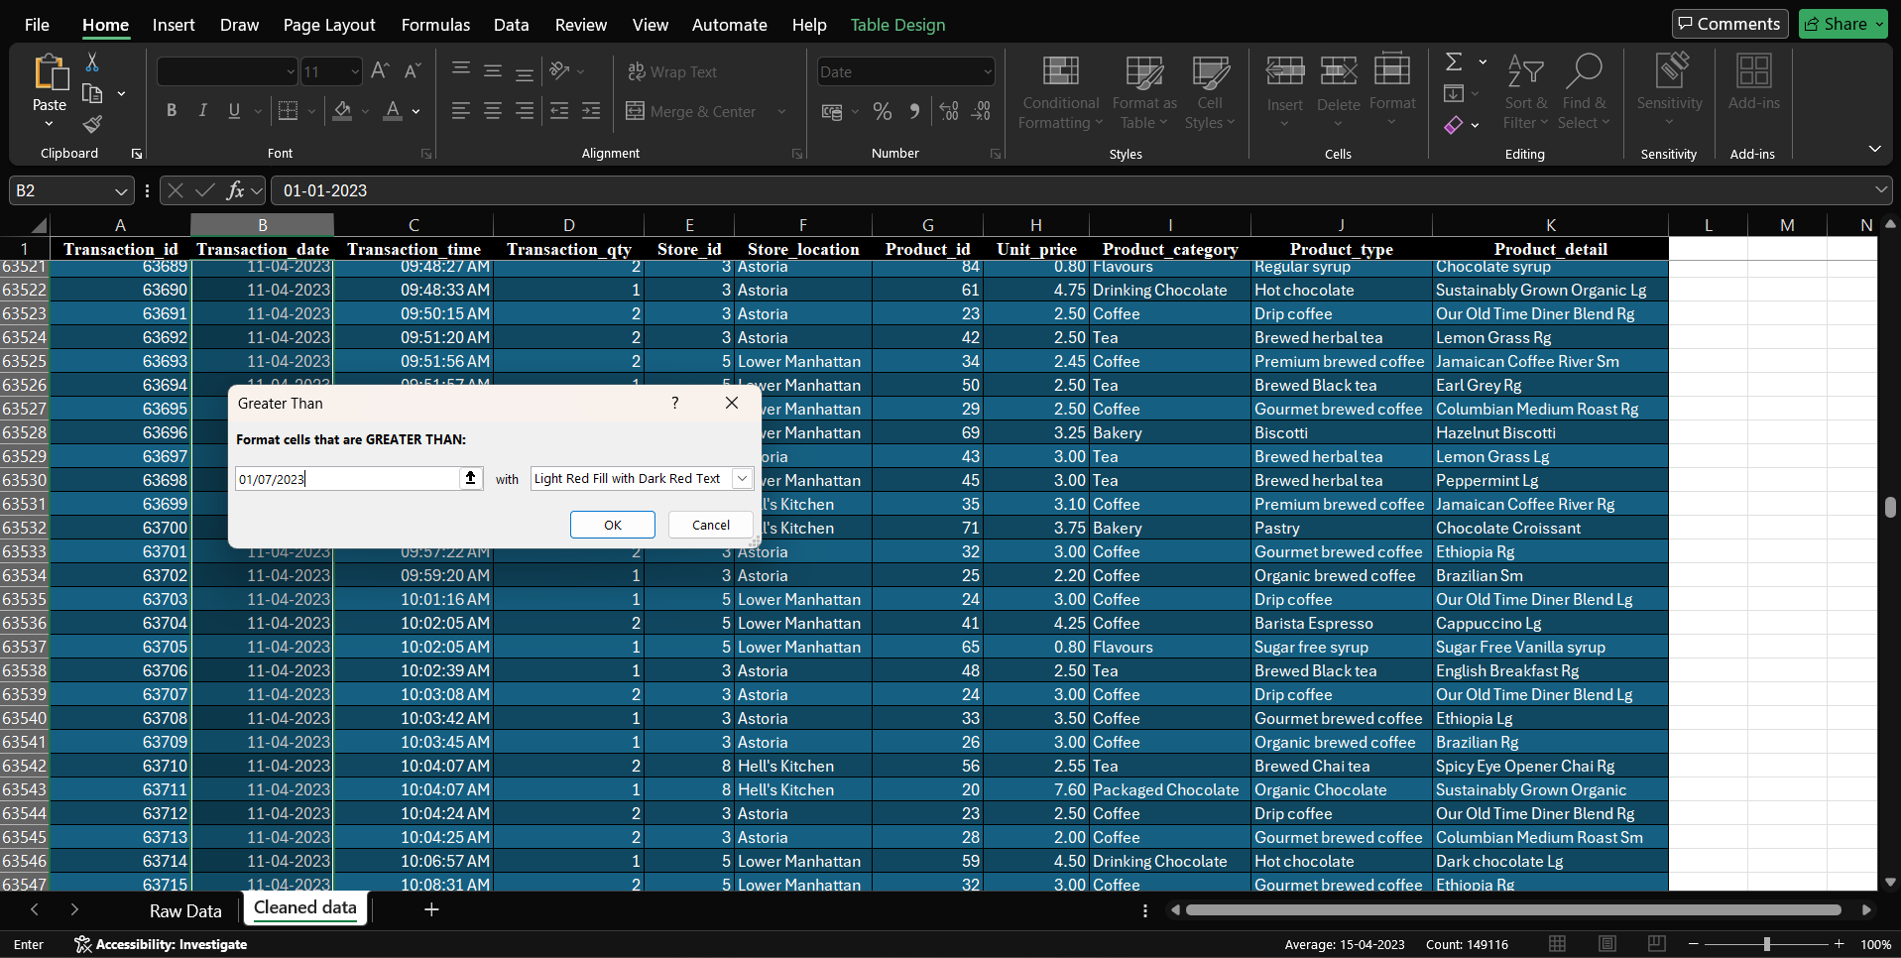

2.5) Text Standardization:
Text standardization was performed to maintain consistency in the text-based columns of the Coffee Shop Sales dataset. All columns were checked for inconsistent text formats, spelling mistakes and differences in capitalization. The store location value “lower manhattan” was standardized to “Lower Manhattan” by capitalizing the first letter of each word. Similarly, the spelling “cofee” was corrected to “Coffee” wherever it appeared. These corrections help maintain uniformity in the dataset, prevent the same category or location from being treated as different values during analysis and improve the accuracy of PivotTables, charts and dashboard reports.
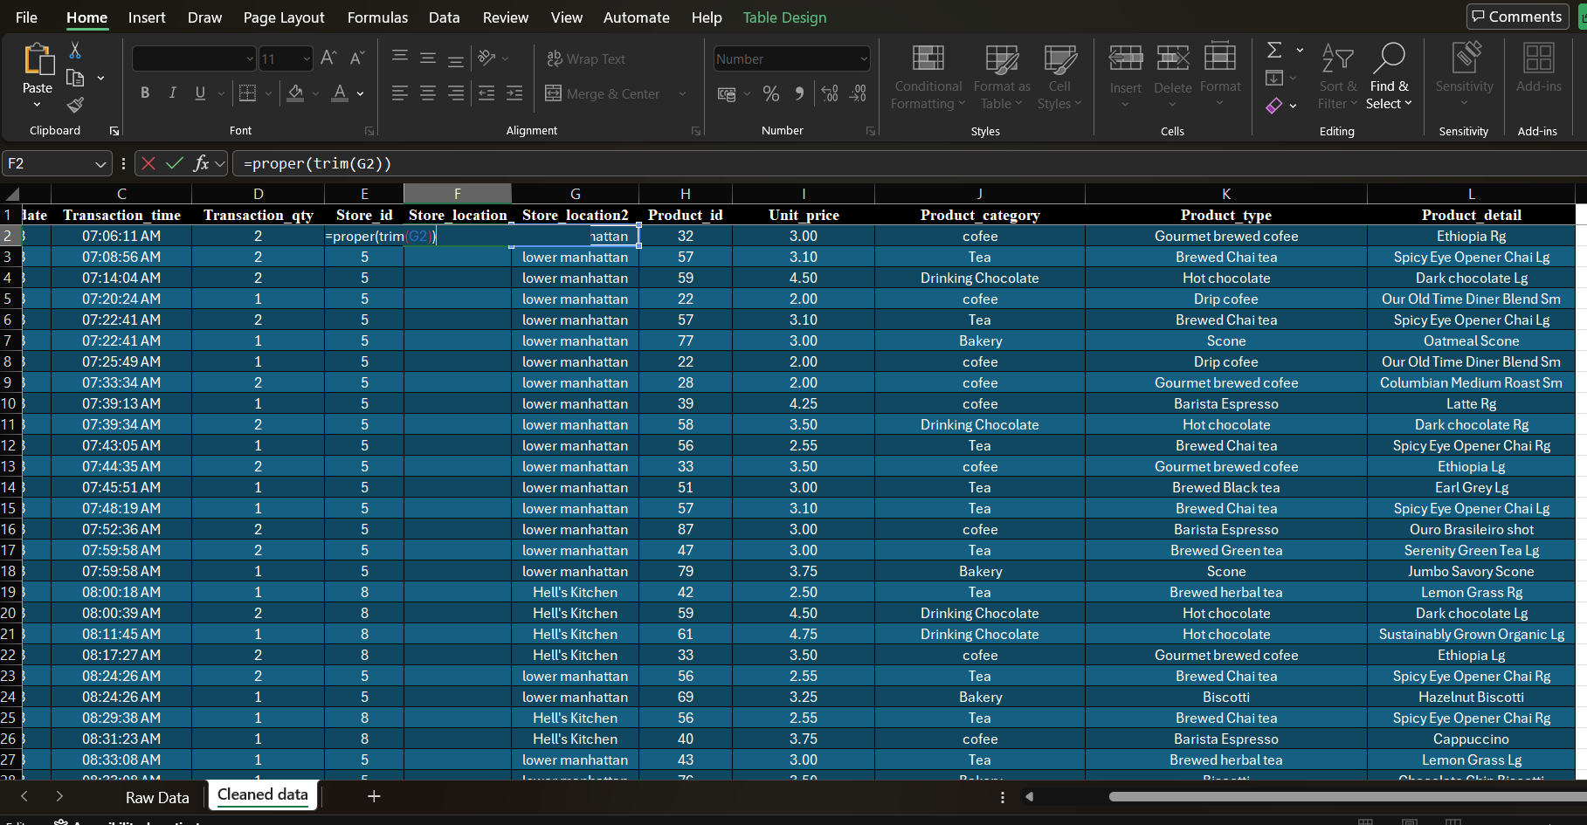

3) Excel Analysis & Formulas
3.1) Total Revenue Calculation:
A new column named Total_Revenue was created by multiplying Transaction_qty by Unit_price using the Excel formula =D2*H2. The column was formatted as a Number with two decimal places to display revenue values clearly. This calculated column helps analyse total sales revenue and compare the performance of products, categories and store locations.

3.2) Total Revenue Using SUM
The Excel SUM function was used to calculate the total revenue generated across all transaction records by adding the values in the Total_Revenue column. This provides an overall sales revenue measure that can be used for further analysis and as a key performance indicator in the dashboard.

3.3) Store Revenue Analysis Using SUMIF
The Excel SUMIF function was used to calculate the total revenue generated by the Astoria store based on the store_location column. The function adds the corresponding values from the Total_Revenue column that match the specified store location. This helps compare sales performance across different store locations.

3.4) Revenue Analysis Using SUMIFS
The Excel SUMIFS function was used to calculate revenue based on multiple conditions, including store location and product category. In this analysis, the function calculated the revenue generated by Coffee products at the Astoria store. This helps identify product category performance within a specific store.

3.5) Average Revenue Analysis Using AVERAGE
The Excel AVERAGE function was used to calculate the average revenue per transaction record using the Total_Revenue column. This helps understand the typical revenue value across the dataset and supports the analysis of overall sales performance.

3.6) Transaction ID Count Using COUNT
The Excel COUNT function was used to count numeric values in the Transaction_id column. This helps validate the number of records containing numeric transaction IDs in the dataset. The result should be checked against the actual number of records in the cleaned worksheet.

3.7) Transaction Count by Store Using COUNTIF
The Excel COUNTIF function was used to count the transaction records associated with the Astoria store by checking the store_location column against the specified store name. This helps compare the number of transaction records across store locations.

3.8) Revenue Classification Using IFS
The Excel IFS function was used to classify transaction records into Low, Medium and High revenue levels based on the calculated Total_Revenue values. Transactions with revenue below 5 were classified as Low, values from 5 to below 10 as Medium and values of 10 or more as High. This classification simplifies transaction-level analysis.

3.9) Transaction Quantity Classification Using IF
The Excel IF function was used to classify transactions based on their quantity. Transactions with a quantity of five or more items were labelled as High Quantity, while the remaining transactions were labelled as Normal Quantity. The formula was applied to the transaction records to support purchasing pattern analysis.

3.10) Product Information Retrieval Using XLOOKUP
The Excel XLOOKUP function was used to search for a product ID in the Product_id column and retrieve the corresponding product detail from the Product_detail column. This simplifies product information retrieval and demonstrates the use of lookup functions in sales data analysis.

3.11) Month-End Date Calculation Using EOMONTH
The Excel EOMONTH function was used to calculate the final date of the month for each transaction date. This calculated column supports monthly grouping and helps analyse sales revenue and transaction trends over the January–June 2023 period.

3.12) Store Revenue Ranking Using RANK.EQ
The Excel RANK.EQ function was used to rank the three store locations based on their total revenue. The store with the highest revenue receives rank 1. This helps compare store performance and identify the highest-revenue location.

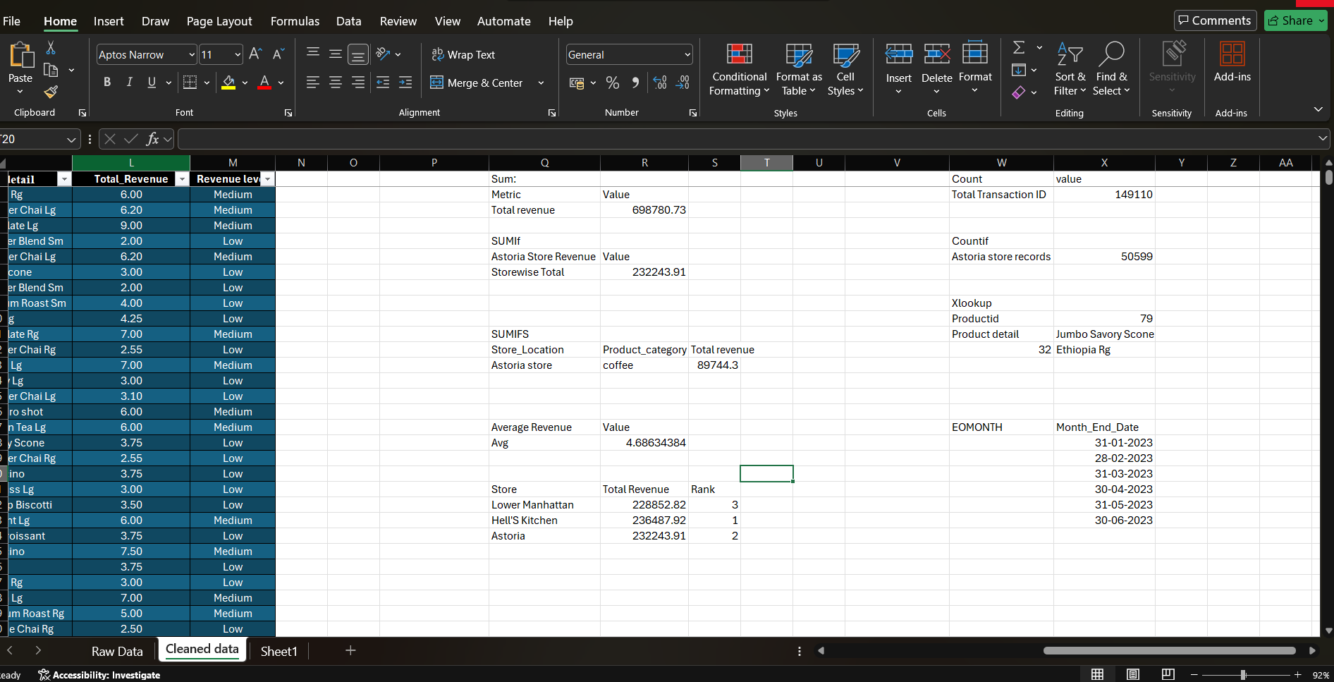

4) PIVOT TABLES & PIVOT CHARTS
4.1) Total Revenue by Store Location
A PivotTable was created to calculate the total revenue generated by each store location. The Store Location field was placed in the Rows area and Total_Revenue was placed in the Values area using the Sum calculation. This analysis compares the revenue performance of Astoria, Hell's kitchen and Lower Manhattan. The results help identify which store generates the highest revenue and which store may need further sales analysis.
A Clustered Column Chart was created to represent total revenue by store location. Store locations are displayed on the horizontal axis, while total revenue is displayed on the vertical axis. Data labels were added to show the revenue values clearly.
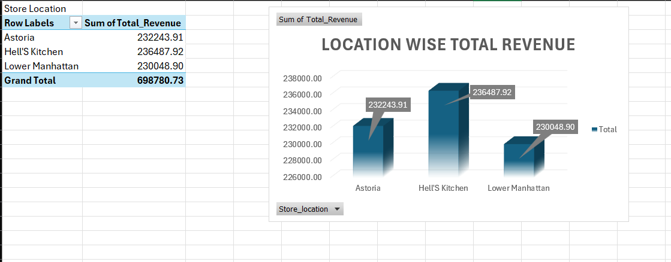
Key finding: Hell's Kitchen generated the highest revenue at 236,487.92, followed by Astoria at 232,243.91. Lower Manhattan generated 230,048.90.

4.2) Revenue Contribution by Product Category
A PivotTable was created to summarize total revenue for each product category. The Product Category field was placed in the Rows area and Total_Revenue was added to the Values area using the Sum calculation. This analysis helps identify the product categories that contribute most to the coffee shop's total revenue. It supports decisions about product performance and category-level sales planning.
A Pie Chart was created to display the revenue contribution of each product category. The different slices represent the categories and the percentage labels show their respective shares of the total revenue.

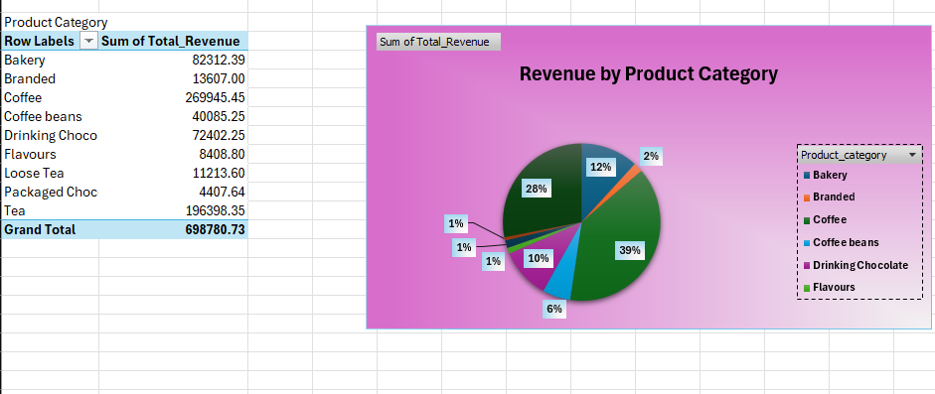
4.3) Total Quantity Sold by Product Type
A PivotTable was created to calculate the total quantity sold for each product type. The Product Type field was placed in the Rows area and Transaction_qty was added to the Values area using the Sum calculation. This analysis helps identify product types with higher and lower sales quantities. The results provide information about product demand and can support inventory planning.
A horizontal Bar Chart was created to compare the total quantity sold across product types. Product types are displayed on the vertical axis, while the total quantities sold are represented by the horizontal bars. Data labels were added to make the quantities easier to compare.
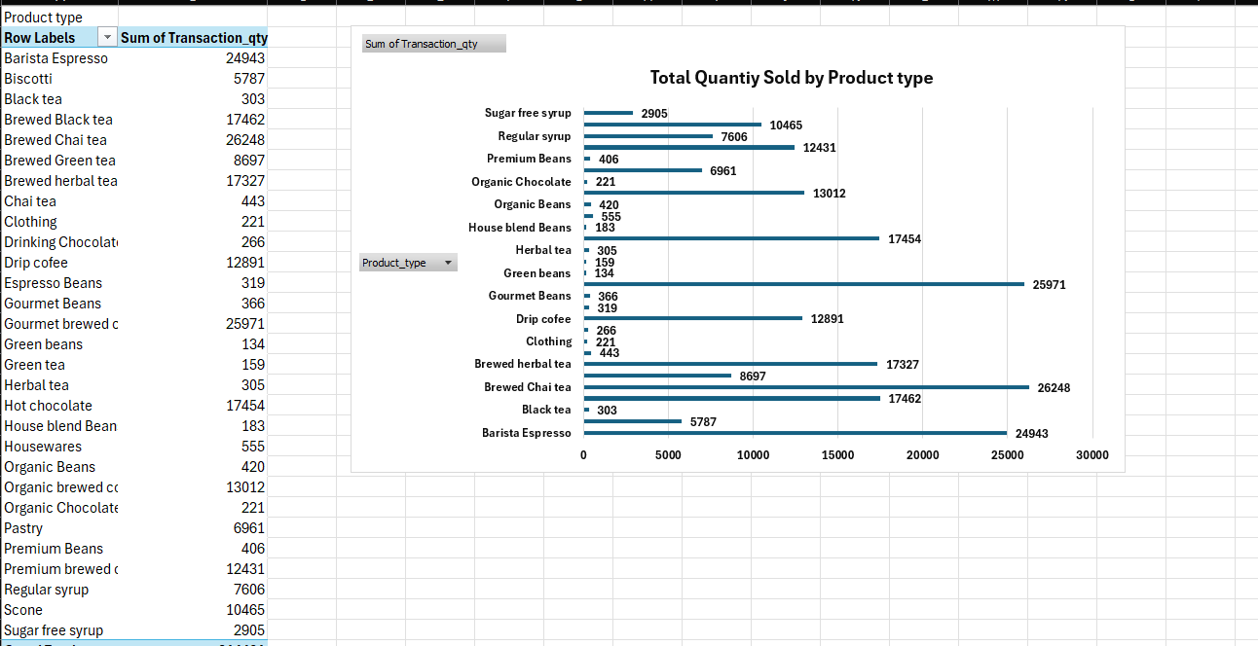

4.4) Monthly Revenue Trend
A PivotTable was created to analyze total revenue month by month. The Transaction_date field was grouped by month and Total_Revenue was placed in the Values area using the Sum calculation. This analysis shows how revenue changes over time and helps identify months with higher or lower sales performance.
A Line Chart was created to display the monthly revenue trend from January to June 2023. The months are displayed on the horizontal axis and total revenue is displayed on the vertical axis. Data labels were added to show the monthly revenue values
Key finding: Revenue decreased from January to February, then increased each month from March through June. June recorded the highest monthly revenue at 166,485.88, while February recorded the lowest at 76,145.19.

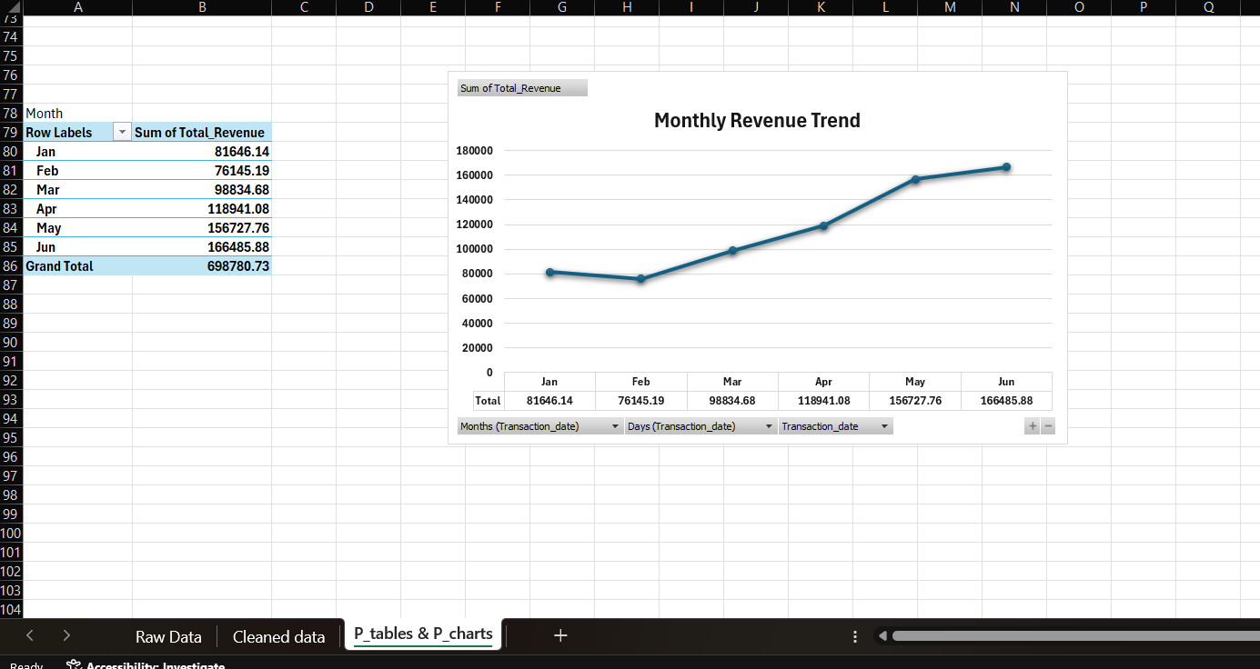

5) Interactive Dashboard
Dashboard Development
The Coffee Shop Sales Dashboard was created in Microsoft Excel to present the results of the sales analysis in one worksheet. It combines key performance indicators (KPIs), charts, slicers and a date timeline to provide a clear overview of the coffee shop's sales performance. The dashboard helps users understand revenue, quantity sold, transaction volume, product demand and store performance without having to examine the raw data manually.
5.1) Key Performance Indicator (KPI) Cards
Four KPI cards were created to display the main sales performance measures: Total Revenue, Total Quantity Sold, Total Transactions and Average Revenue per Transaction. These indicators provide a quick summary of overall business performance.
- Total Revenue: Displays the total revenue generated by the coffee shop.
- Total Quantity Sold: Shows the total number of product units sold.
- Total Transactions: Displays the number of transaction records.
- Average Revenue per Transaction: Shows the average revenue generated per transaction record.
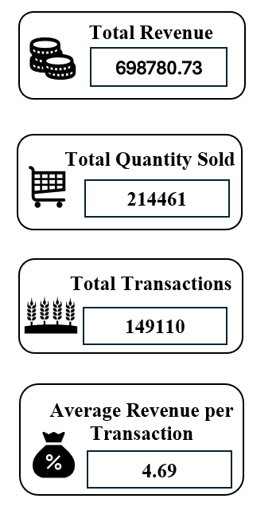
5.2) Slicers and Timeline Interaction
1.Store Location Slicer:
A Store Location slicer was added to the dashboard to analyse sales performance across different store locations. It allows users to select a specific store, such as Astoria, Hell's Kitchen, or Lower Manhattan. When a store is selected, the connected PivotTables and charts update to display the corresponding sales information. This helps compare store performance and understand the revenue generated by each location.
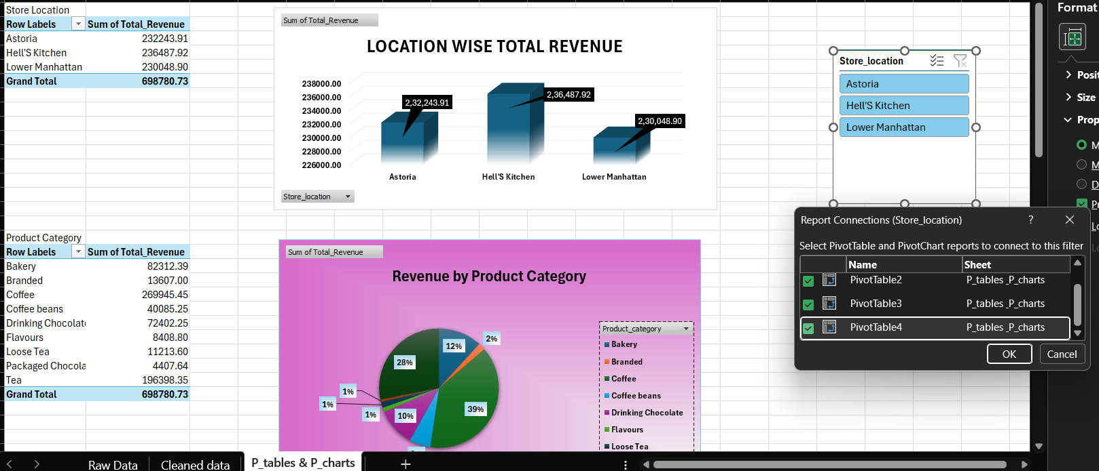
2. Product Category Slicer:
A Product Category slicer was added to filter the sales data based on product categories, such as Coffee, Tea, Bakery and other available categories. Users can select a category to view its corresponding revenue and sales performance. The connected PivotTables and charts update according to the selected category. This interaction helps identify the contribution of different product categories to the coffee shop's overall sales.
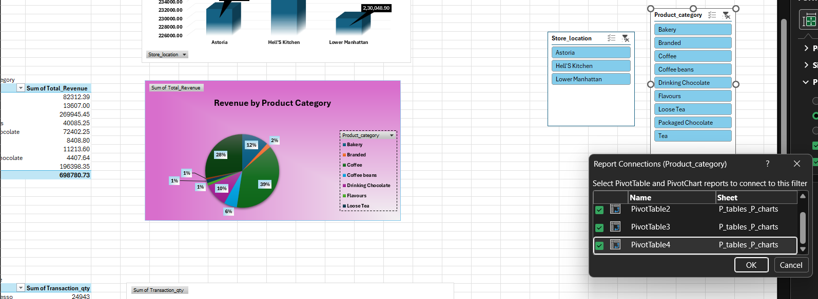

3. Product Type Slicer:
A Product Type slicer was added to analyse sales performance for individual product types within the dataset. It allows users to select a specific product type and examine its sales revenue and quantity sold. When a selection is made, the connected PivotTables and charts display the corresponding results. This helps identify popular products, compare product demand and support inventory planning.
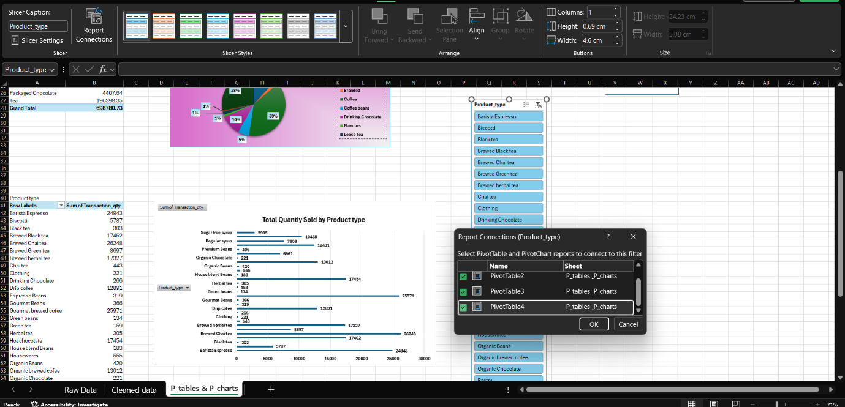

4.Transaction_date Timeline:
A Transaction Date Timeline was added to the dashboard to analyse sales performance over a specific period. It allows users to filter transaction records by selecting the required months or date ranges. When a date range is selected, the connected PivotTables and charts update to display the corresponding sales information for that period. This feature helps track monthly revenue changes, compare sales performance over time and identify periods with higher or lower sales activity.

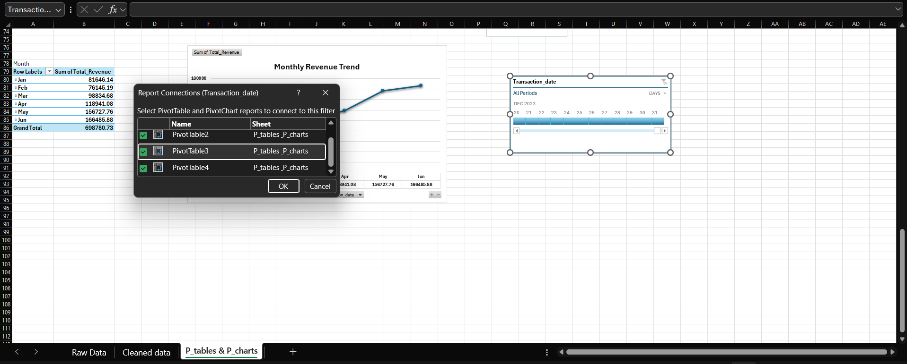
5.3) Dashboard Charts and Formatting
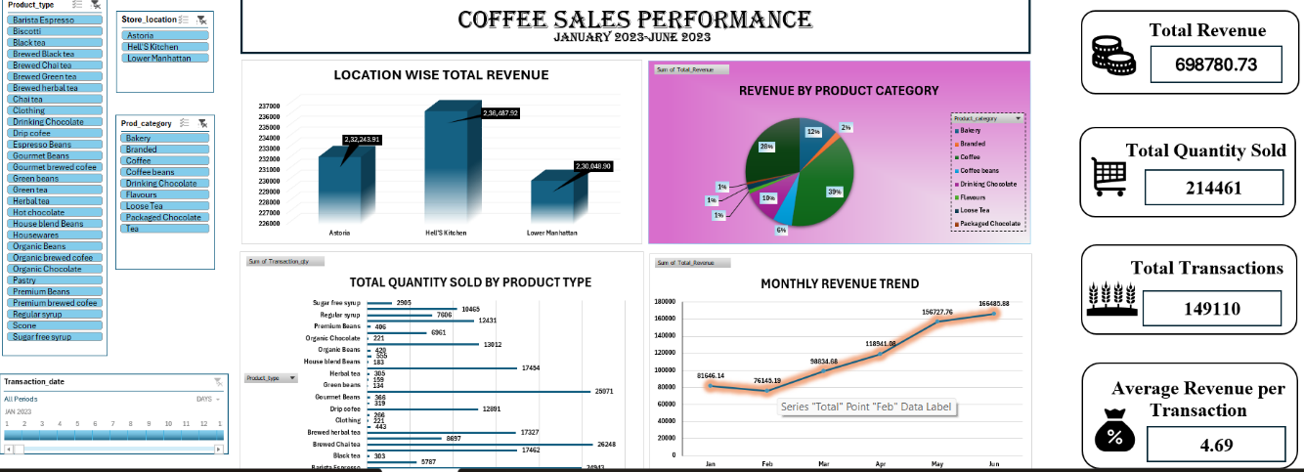
The dashboard brings together visual representations of sales performance, including revenue by store location, revenue contribution by product category, quantity sold by product type and monthly revenue trends. The charts were arranged within the dashboard worksheet and formatted using suitable chart titles, labels, colours and clear layouts. This presentation makes the results easier to understand and helps users identify differences in store performance, product demand and monthly sales.

The dashboard uses a consistent colour theme to distinguish different sales measures and improve visual clarity. KPI cards are positioned on the right side to display important performance indicators briefly. Slicers and the transaction date timeline are arranged on the left side to allow users to filter the sales data interactively. Chart labels and titles help users understand the information without referring to the raw dataset. Overall, the dashboard provides a structured and user-friendly view of coffee shop sales performance.

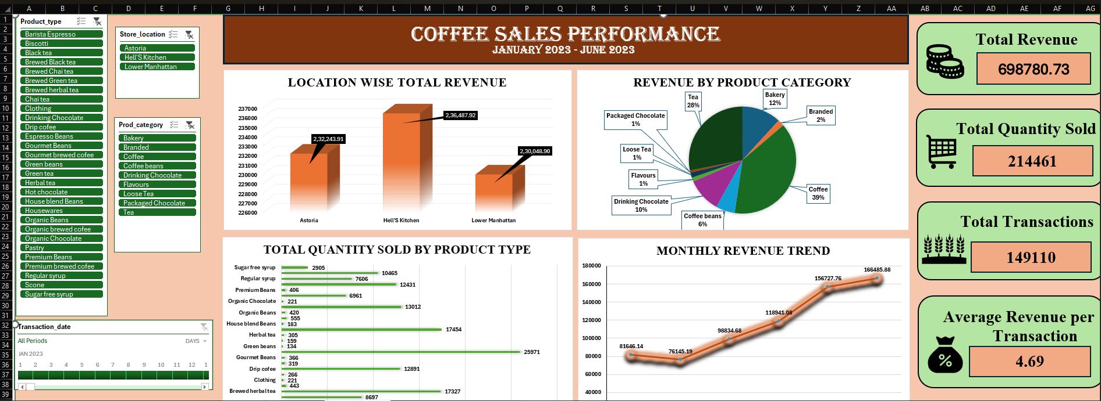
6) Insights Reports
6.1) Key Findings and Business Insights
1.Overall Sales Performance
The analysis recorded total revenue of 698,780.73 from January to June 2023. The dashboard summarizes revenue, quantity sold, transaction records and average revenue per transaction, providing an overview of sales performance during the analysis period.
2. Store Performance Analysis
Hell's Kitchen generated the highest revenue of 236,487.92, followed by Astoria at 232,243.91 and Lower Manhattan at 230,048.90. The difference between the highest- and lowest-revenue stores was 6,439.02. This indicates that the revenue totals were relatively close across the three locations.
3. Product Category Performance
Coffee generated the highest revenue among the product categories, contributing 269,945.45, followed by Tea at 196,398.35. Coffee accounted for approximately 38.6% of total revenue. This shows that Coffee was an important revenue-generating category during the analysis period.
4. Product Demand Analysis
Brewed Chai tea recorded the highest quantity among the product types shown in the PivotTable, with 26,248 units sold. This finding highlights the importance of examining sales quantities alongside revenue when understanding product demand.
5. Monthly Revenue Trends
Monthly revenue decreased from 81,646.14 in January to 76,145.19 in February. It then increased each month from March through June. June recorded the highest monthly revenue of 166,485.88. These results show a clear increase in recorded monthly revenue after February, although the data alone does not explain the reasons for this change.
6. Overall Business Interpretation
The analysis shows differences in revenue across product categories and store locations, as well as changes in monthly sales. Coffee was the leading category by revenue, Brewed Chai tea had the highest recorded quantity sold among the listed product types, and the three store locations had relatively similar revenue totals. These findings provide a basis for sales monitoring and business planning.

6.2) Business Recommendations
1. Maintain Availability of High-Demand Products
The business should monitor stock levels for products with high sales quantities, including Brewed Chai tea. Inventory decisions should consider sales quantities, stock levels, shelf life and supplier lead times to help reduce stock shortages and unnecessary excess inventory.
2. Strengthen Product Category Planning
Since Coffee generated the highest revenue among the product categories, management should monitor its sales performance and maintain suitable stock levels. Other categories, including Tea, should also be reviewed to understand their contribution to overall sales.
3. Review Store Performance Consistently
Hell's Kitchen recorded the highest revenue, while Lower Manhattan recorded the lowest. Because the revenue difference was relatively small, management should compare additional measures, such as transaction volume, customer footfall, operating hours and costs, before deciding whether any store requires corrective action.
4. Use Monthly Trends for Operational Planning
Management should continue monitoring monthly revenue to identify changes in sales activity. The higher revenue recorded from March through June can inform future planning but staffing and inventory decisions should also consider daily and hourly demand where that information is available.
5. Investigate Changes in Sales Performance
The business should investigate possible reasons for the lower revenue in February and the increase in subsequent months. Additional information, such as promotions, store operating conditions, product availability and customer traffic, would help explain the changes more accurately.
6. Maintain and Update the Dashboard
The Excel dashboard should be refreshed regularly when new transaction data becomes available. Reviewing the KPI cards, PivotTables, charts, slicers and date timeline can help management monitor sales performance and compare stores, categories and product types.

7) Conclusion
The Coffee Shop Sales & Customer Transaction Analytics project was completed to understand coffee shop sales performance and identify useful business insights from customer transaction data. This project provided practical experience in using Microsoft Excel to perform data cleaning, data transformation, formula-based calculations, PivotTable analysis, chart creation and interactive dashboard development. The main objective was to convert raw sales data into meaningful information that can help understand sales performance across different store locations, product categories, product types and months.
The project started with understanding the dataset, which contained transaction details such as transaction date, store location, product category, product type, transaction quantity and unit price. The data cleaning process included checking missing values, removing duplicate records, converting data types, checking invalid values and standardizing text values. These steps helped prepare the dataset for further analysis and improve the consistency of the data used in the project.
After completing data cleaning, different Excel formulas were applied to calculate and analyze sales information. Formulas such as SUM, SUMIF, SUMIFS, AVERAGE, COUNT, COUNTIF, IF, IFS, XLOOKUP, EOMONTH and RANK.EQ were used for calculations, comparisons, date-related analysis and retrieving information. The Total Revenue column was calculated using transaction quantity multiplied by unit price. Practicing these formulas improved my understanding of how Excel can be used to process data and answer business-related questions.
PivotTables and charts were then created to analyze the dataset from different perspectives. The analysis helped compare revenue across store locations, examine revenue by product category, identify product demand and understand monthly sales trends. The results showed that Hell’s Kitchen recorded the highest revenue among the three store locations, while Coffee generated more revenue than Tea. The monthly analysis also showed that revenue increased from February to June 2023, with June recording the highest monthly revenue in the analyzed period.
An interactive dashboard was developed in a single worksheet to present the important results in a clear and organized format. The dashboard included KPI cards for Total Revenue, Total Quantity Sold, Total Transactions and Average Revenue per Transaction. Different charts were used to display sales information, while slicers for Store Location, Product Category and Product Type, along with a transaction-date timeline, allowed users to filter the information and explore specific parts of the dataset. Suitable chart titles, labels, colours and layouts were applied to make the dashboard easier to understand.
Overall, this project helped me gain practical knowledge of the complete data analysis process, from understanding and cleaning raw data to analyzing results and presenting them through an interactive dashboard. It also improved my skills in Excel formulas, PivotTables, charts, KPI reporting and data visualization. Through this project, I learned how sales data can be converted into useful information for understanding business performance and supporting decision-making.
In conclusion, the project successfully demonstrated how Microsoft Excel can be used to organize, analyze and present coffee shop sales data. The completed report and dashboard provide a clear overview of sales performance during the analyzed period and can help users explore the data more effectively. This project also strengthened my practical data analytics skills and provided a foundation for working on more advanced data analysis projects in the future.

DASHBOARD

OUTPUT:

